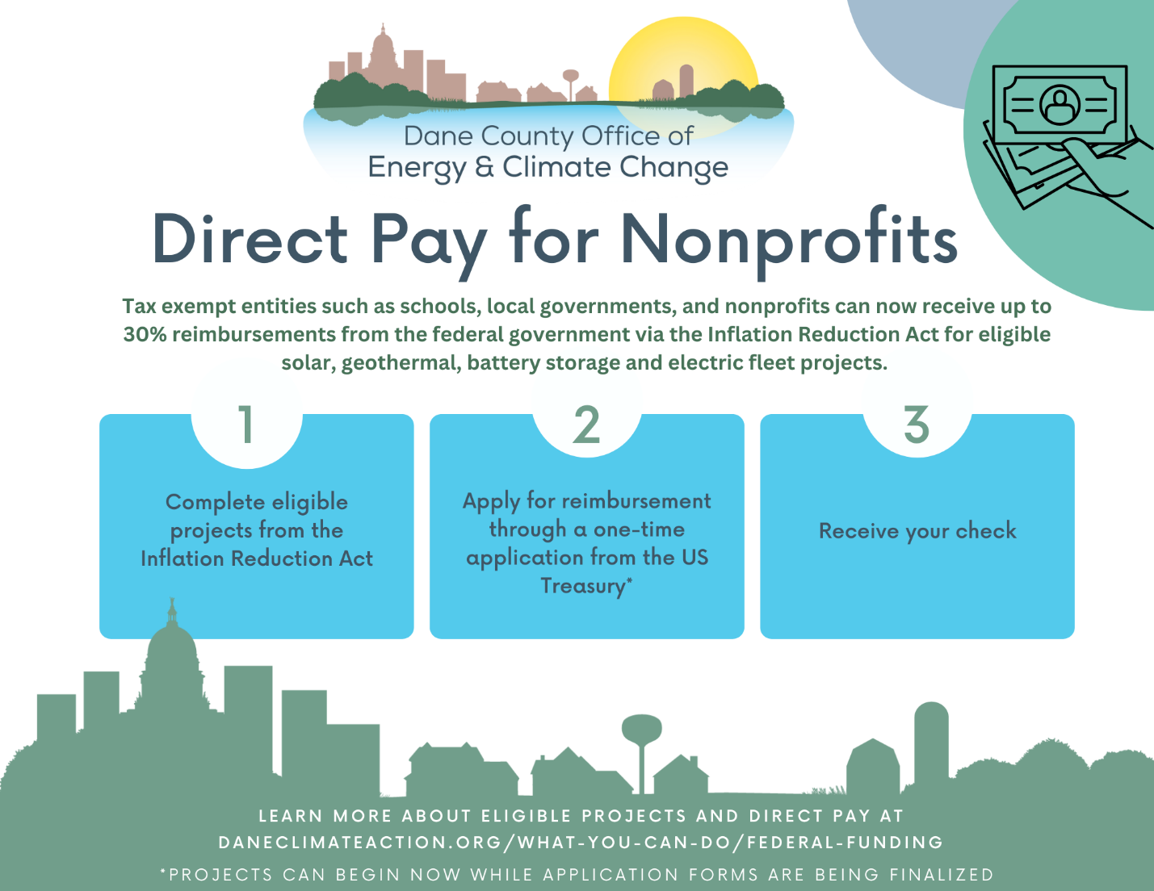

Did you know that tax-exempt entities are now eligible to receive reimbursements from the federal government for eligible solar, geothermal, battery storage, and electric fleet projects?  
  
Projects can begin now even though reimbursement forms are not quite available yet. Learn more about Direct Pay on the Dane County Office of Energy & Climate Change website at daneclimateaction.org/what-you-can-do/federal-funding-for-business under Project Financing.